**PROPOSAL PEMROGRAMAN BERORIENTASI OBJEK JAVA II**



APLIKASI PERBANKAN

**APLIKASI GAME BINGO**

Dibuat Oleh :

1. Geovanny Valerian (535160051)
2. Jason (535160076)
3. Yobel Octavinus (535160082)

**Universitas Tarumanegara**

**Jakarta**

**2018/2019**

**PENDAHULUAN**

* 1. **Latar Belakang**

Di Amerika Serikat, Bingo adalah permainan peluang di mana setiap pemain mencocokkan angka yang dicetak dalam pengaturan berbeda pada latar 5 × 5 (1 hingga 25) dengan menandai angka yang dipilih. Ketika seorang pemain menemukan nomor yang dipilih, kemudian kartu mereka tersusun membentuk 5 garis (vertical, horizontal dan diagonal), mereka akan berteriak "Bingo!" untuk memperingatkan semua peserta bahwa pemain tersebut telah menang, yang meminta host game (atau rekan yang membantu tuan rumah) memeriksa kartu untuk memverifikasi kemenangan. Pemain bersaing satu sama lain untuk menjadi yang pertama memiliki 5 garis bingo. Setelah pemenang dinyatakan, para pemain menghapus kartu nomor mereka dari latar dan tuan rumah permainan memulai babak permainan baru.

**1.2 Tujuan dan Manfaat**

* **TUJUAN**

Merancang dan menghasilkan game Bingo dengan berbasis Java, yang menarik dan dapat menghibur para pemainnya.

* **MANFAAT**

Pemain dapat terhibur dengan memainkan aplikasi game Bingo yang dibuat.

**FITUR – FITUR**

Fitur yang terdapat pada Aplikasi Games kami yang bernama Bingo adalah:

1. Fitur :
2. Login:

* Login pada User:
* Dapat bermain menggunakan akun User
* Dapat melihat skor User
* Login pada Admin:
* Dapat Membuat, menghapus dan mengedit akun User

1. Halaman Utama :

* Play: Tombol untuk memulai permainan
* Highscore: Untuk melihat skor tertinggi dari User

1. Halaman pemilihan angka:

* Random: Angka akan dipilih secara acak dari 1 hingga 25
* Choose yourself: User dapat memilih sendiri angka yang ingin diletakkan pada kotak yang tersedia

1. Logout:

* Tombol untuk keluar dari akun User

**SOURCE CODE DAN TAMPILAN**

1. **Fitur User**
2. **Login**

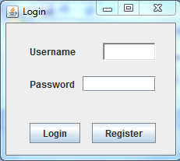

import javax.swing.*;  
import javax.swing.border.EmptyBorder;  
import java.awt.*;  
  
public class login extends JFrame {  
  
 JButton brand;  
 JButton bchoo;  
  
 TextField tuser;  
 JPasswordField tpass;  
  
 JLabel luser,lpass;  
 static JFrame f;  
  
 static JLabel l;  
  
 JLabel imageLabel = new JLabel();  
  
 public login() {  
  
 f = new JFrame("Login");  
  
 JPanel p = new JPanel();  
 JPanel a = new JPanel();  
 JPanel b = new JPanel();  
  
 JPanel mainPanel = new JPanel();  
 mainPanel.setLayout(new BoxLayout(mainPanel, BoxLayout.Y_AXIS));  
  
 brand = new JButton("Login");  
 bchoo = new JButton("Register");  
 luser = new JLabel("Username", JLabel.CENTER);  
 lpass = new JLabel("Password",JLabel.CENTER);  
 tuser = new TextField();  
 tpass = new JPasswordField();  
  
 setDefaultCloseOperation(EXIT_ON_CLOSE);  
  
 BoxLayout boxlayout = new BoxLayout(p, BoxLayout.X_AXIS);  
 BoxLayout boxlayout1 = new BoxLayout(a, BoxLayout.X_AXIS);  
 BoxLayout boxlayout2 = new BoxLayout(b, BoxLayout.X_AXIS);  
  
 a.setBorder(new EmptyBorder(new Insets(5, 30, 15, 25)));  
  
 p.setBorder(new EmptyBorder(new Insets(25, 30, 15, 25)));  
  
 b.setBorder(new EmptyBorder(new Insets(25, 30, 15, 25)));  
 p.setLayout(boxlayout);  
 a.setLayout(boxlayout1);  
 b.setLayout(boxlayout2);  
  
 f.setSize(300, 300);  
 p.add(luser);  
 p.add(Box.createRigidArea(new Dimension(35, 0)));  
 p.add(tuser);  
 a.add(lpass);  
 a.add(Box.createRigidArea(new Dimension(10, 0)));  
 a.add(tpass);  
 b.add(brand);  
 b.add(Box.createRigidArea(new Dimension(15, 0)));  
 b.add(bchoo);  
  
 mainPanel.add(p);  
 mainPanel.add(a);  
 mainPanel.add(b);  
 f.add(mainPanel);  
 f.pack();  
 this.setLocationRelativeTo(null);  
 f.setVisible(true);  
 }  
}

1. **Register**

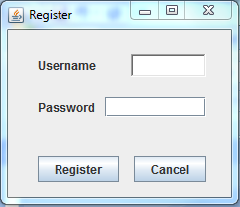

import javax.swing.*;  
import javax.swing.border.EmptyBorder;  
import java.awt.*;  
  
public class Register extends JFrame {  
  
 JButton brand;  
 JButton bchoo;  
  
 TextField tuser;  
 JPasswordField tpass;  
  
 JLabel luser,lpass;  
 static JFrame f;  
  
 static JLabel l;  
  
 JLabel imageLabel = new JLabel();  
  
 public Register() {  
  
 f = new JFrame("Register");  
  
 JPanel p = new JPanel();  
 JPanel a = new JPanel();  
 JPanel b = new JPanel();  
  
 JPanel mainPanel = new JPanel();  
 mainPanel.setLayout(new BoxLayout(mainPanel, BoxLayout.Y_AXIS));  
  
 brand = new JButton("Register");  
 bchoo = new JButton("Cancel");  
 luser = new JLabel("Username", JLabel.CENTER);  
 lpass = new JLabel("Password",JLabel.CENTER);  
 tuser = new TextField();  
 tpass = new JPasswordField();  
  
 setDefaultCloseOperation(EXIT_ON_CLOSE);  
  
 BoxLayout boxlayout = new BoxLayout(p, BoxLayout.X_AXIS);  
 BoxLayout boxlayout1 = new BoxLayout(a, BoxLayout.X_AXIS);  
 BoxLayout boxlayout2 = new BoxLayout(b, BoxLayout.X_AXIS);  
  
 a.setBorder(new EmptyBorder(new Insets(5, 30, 15, 25)));  
  
 p.setBorder(new EmptyBorder(new Insets(25, 30, 15, 25)));  
  
 b.setBorder(new EmptyBorder(new Insets(25, 30, 15, 25)));  
 p.setLayout(boxlayout);  
 a.setLayout(boxlayout1);  
 b.setLayout(boxlayout2);  
  
 f.setSize(300, 300);  
 p.add(luser);  
 p.add(Box.createRigidArea(new Dimension(35, 0)));  
 p.add(tuser);  
 a.add(lpass);  
 a.add(Box.createRigidArea(new Dimension(10, 0)));  
 a.add(tpass);  
 b.add(brand);  
 b.add(Box.createRigidArea(new Dimension(15, 0)));  
 b.add(bchoo);  
  
 mainPanel.add(p);  
 mainPanel.add(a);  
 mainPanel.add(b);  
 f.add(mainPanel);  
 f.pack();  
 this.setLocationRelativeTo(null);  
 f.setVisible(true);  
 }  
}

1. **Main Menu**

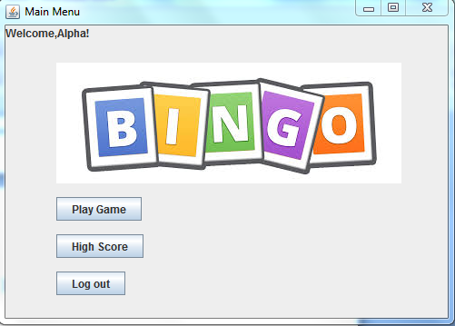

import javax.swing.*;  
import java.awt.*;  
import java.awt.Component;  
import java.awt.Container;  
import javax.swing.BoxLayout;  
import javax.swing.JButton;  
import javax.swing.JFrame;  
import javax.swing.border.EmptyBorder;  
  
public class menu extends JFrame {  
 JButton btns;  
 JButton btnm;  
 JButton btnhs;  
  
 static JFrame f;  
  
 static JLabel l,u;  
  
 public menu() {

f = new JFrame("Main Menu");  
  
 ImageIcon i = new ImageIcon("download.jpg");  
  
 l = new JLabel(i);  
 u = new JLabel("Welcome,Alpha!",JLabel.LEFT);  
  
 JPanel p = new JPanel();  
  
 btns = new JButton("Play Game");  
 btnm = new JButton("Log out");  
 btnhs = new JButton("High Score");  
  
 setDefaultCloseOperation(EXIT_ON_CLOSE);  
  
 BoxLayout boxlayout = new BoxLayout(p, BoxLayout.Y_AXIS);  
  
 p.setBorder(new EmptyBorder(new Insets(25, 50, 25, 50)));  
  
 p.setLayout(boxlayout);  
  
 p.add(l);  
  
 f.setSize(300, 300);  
  
 p.add(Box.createRigidArea(new Dimension(15,15)));  
 p.add(btns);  
 p.add(Box.createRigidArea(new Dimension(15,15)));  
 p.add(btnhs);  
 p.add(Box.createRigidArea(new Dimension(15,15)));  
 p.add(btnm);  
  
 f.add(u,BorderLayout.PAGE_START);  
 f.add(p);  
 f.pack();  
 f.setVisible(true);  
 }  
}

1. **Choose Bingo**

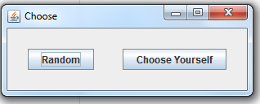

import javax.swing.*;  
import javax.swing.border.EmptyBorder;  
import java.awt.*;  
  
public class choose1 extends JFrame {  
  
 JButton brand;  
 JButton bchoo;  
  
 static JFrame f;  
  
 public choose1(){  
 f = new JFrame("Choose");  
  
 JPanel p = new JPanel();  
  
 brand = new JButton("Random");  
 bchoo = new JButton("Choose Yourself");

setDefaultCloseOperation(EXIT_ON_CLOSE);  
  
 BoxLayout boxlayout = new BoxLayout(p, BoxLayout.X_AXIS);  
  
 p.setBorder(new EmptyBorder(new Insets(25, 25, 25, 25)));  
  
 p.setLayout(boxlayout);  
  
 f.setSize(200, 150);  
 p.add(brand);  
 p.add(Box.createRigidArea(new Dimension(35,0)));  
 p.add(bchoo);  
  
 f.add(p);  
 f.pack();  
 f.setVisible(true);  
 }  
}

1. **Edit Bingo**

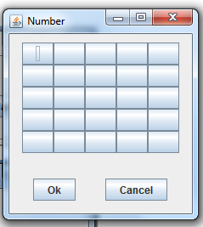

import javax.swing.*;  
import javax.swing.border.EmptyBorder;  
import java.awt.*;  
import java.util.Timer;  
  
public class Choose extends JFrame {  
 JButton b1,b2,b3,b4,b5,b6,b7,b8,b9,b11,b12,b13,b14,b15,b16,b17,b18,b19,b20,b21,b22,b23,b24,b25;  
   
 JButton brand,bchoo;  
  
 static JFrame f;  
  
 public Choose(){  
  
 f = new JFrame("Number");  
  
 JPanel p = new JPanel();  
 JPanel a = new JPanel();  
  
 JPanel mainPanel = new JPanel();  
 mainPanel.setLayout(new BoxLayout(mainPanel, BoxLayout.Y_AXIS));  
  
 b1 = new JButton(" ");  
 b2 = new JButton(" ");  
 b3 = new JButton(" ");  
 b4 = new JButton(" ");  
 b5 = new JButton(" ");  
 b6 = new JButton(" ");  
 b7 = new JButton(" ");  
 b8 = new JButton(" ");  
 b9 = new JButton(" ");  
 b10 = new JButton(" ");  
 b11 = new JButton(" ");  
 b12 = new JButton(" ");  
 b13 = new JButton(" ");  
 b14 = new JButton(" ");  
 b15 = new JButton(" ");  
 b16 = new JButton(" ");  
 b17 = new JButton(" ");  
 b18 = new JButton(" ");  
 b19 = new JButton(" ");  
 b20 = new JButton(" ");  
 b21 = new JButton(" ");  
 b22 = new JButton(" ");  
 b23 = new JButton(" ");  
 b24 = new JButton(" ");  
 b25 = new JButton(" ");  
 brand = new JButton("Ok");  
 bchoo = new JButton("Cancel");  
  
 BoxLayout boxlayout = new BoxLayout(a, BoxLayout.X_AXIS);  
  
 a.setLayout(boxlayout);  
  
 a.setBorder(new EmptyBorder(new Insets(15, 15, 15, 15)));  
  
 setDefaultCloseOperation(EXIT_ON_CLOSE);  
  
 p.setBorder(new EmptyBorder(new Insets(10, 15, 15, 15)));  
  
 p.setLayout(new GridLayout(5, 5));  
  
 f.setSize(400, 400);  
 p.add(b1);  
 p.add(b2);  
 p.add(b3);  
 p.add(b4);  
 p.add(b5);  
 p.add(b6);  
 p.add(b7);  
 p.add(b8);  
 p.add(b9);  
 p.add(b10);  
 p.add(b11);  
 p.add(b12);  
 p.add(b13);  
 p.add(b14);  
 p.add(b15);  
 p.add(b16);  
 p.add(b17);  
 p.add(b18);  
 p.add(b19);  
 p.add(b20);  
 p.add(b21);  
 p.add(b22);  
 p.add(b23);  
 p.add(b24);  
 p.add(b25);  
  
 a.add(brand);  
 a.add(Box.createRigidArea(new Dimension(35,15)));  
 a.add(bchoo);  
  
 mainPanel.add(p);  
 mainPanel.add(a);  
 f.add(mainPanel);  
 f.pack();  
 f.setVisible(true);  
 }  
}

1. **Game**

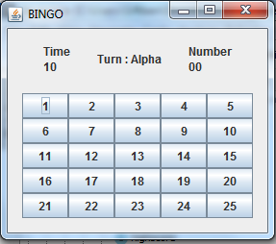

import javax.swing.*;  
import javax.swing.border.EmptyBorder;  
import java.awt.*;  
import java.util.Timer;  
  
public class Game1 extends JFrame {  
 JButton b1,b2,b3,b4,b5,b6,b7,b8,b9,b10,b11,b12,b13,b14,b15,b16,b17,b18,b19,b20,b21,b22,b23,b24,b25;  
  
 static JFrame f;  
  
 static JLabel timec,timel,numberl,numberc,turn;  
  
 public Game1(){  
  
 f = new JFrame("BINGO");  
  
 JPanel p = new JPanel();  
 JPanel a = new JPanel();  
  
 JPanel mainPanel = new JPanel();  
 mainPanel.setLayout(new BoxLayout(mainPanel, BoxLayout.Y_AXIS));  
  
 b1 = new JButton("1");  
 b2 = new JButton("2");  
 b3 = new JButton("3");  
 b4 = new JButton("4");  
 b5 = new JButton("5");  
 b6 = new JButton("6");  
 b7 = new JButton("7");  
 b8 = new JButton("8");  
 b9 = new JButton("9");  
 b10 = new JButton("10");  
 b11 = new JButton("11");  
 b12 = new JButton("12");  
 b13 = new JButton("13");  
 b14 = new JButton("14");  
 b15 = new JButton("15");  
 b16 = new JButton("16");  
 b17 = new JButton("17");  
 b18 = new JButton("18");  
 b19 = new JButton("19");  
 b20 = new JButton("20");  
 b21 = new JButton("21");  
 b22 = new JButton("22");  
 b23 = new JButton("23");  
 b24 = new JButton("24");  
 b25 = new JButton("25");  
  
 BoxLayout boxlayout = new BoxLayout(a, BoxLayout.X_AXIS);  
  
 a.setLayout(boxlayout);  
  
 a.setBorder(new EmptyBorder(new Insets(15, 15, 5, 15)));  
  
 setDefaultCloseOperation(EXIT_ON_CLOSE);  
  
 p.setBorder(new EmptyBorder(new Insets(15, 15, 15, 15)));  
  
 timel = new JLabel("<html>Time<br/> 10 <html>",SwingConstants.CENTER);  
 turn = new JLabel("Turn : Alpha");  
 numberl = new JLabel("<html>Number<br/> 00 <br/><html>",SwingConstants.CENTER);  
  
 a.add(timel);  
 a.add(Box.createRigidArea(new Dimension(5,0)));  
 a.add(turn);  
 a.add(Box.createRigidArea(new Dimension(5,0)));  
 a.add(numberl);  
  
 p.setLayout(new GridLayout(5, 5));  
  
 f.setSize(400, 400);  
 p.add(b1);  
 p.add(b2);  
 p.add(b3);  
 p.add(b4);  
 p.add(b5);  
 p.add(b6);  
 p.add(b7);  
 p.add(b8);  
 p.add(b9);  
 p.add(b10);  
 p.add(b11);  
 p.add(b12);  
 p.add(b13);  
 p.add(b14);  
 p.add(b15);  
 p.add(b16);  
 p.add(b17);  
 p.add(b18);  
 p.add(b19);  
 p.add(b20);  
 p.add(b21);  
 p.add(b22);  
 p.add(b23);  
 p.add(b24);  
 p.add(b25);  
  
 mainPanel.add(a);  
 mainPanel.add(p);  
 f.add(mainPanel);  
 f.pack();  
 f.setVisible(true);  
 }  
}

1. **Retry or Main Menu**

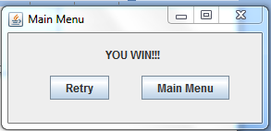

import javax.swing.*;  
import javax.swing.border.EmptyBorder;  
import java.awt.*;  
  
public class retry extends JFrame {  
  
 JButton brand;  
 JButton bchoo;  
  
 JLabel win;  
 static JFrame f;  
  
 static JLabel l;  
  
 JLabel imageLabel = new JLabel();  
  
 public retry(){  
  
 f = new JFrame("Main Menu");  
  
 JPanel p = new JPanel();  
 JPanel a = new JPanel();  
  
 JPanel mainPanel = new JPanel();  
 mainPanel.setLayout(new BoxLayout(mainPanel, BoxLayout.Y_AXIS));  
  
 brand = new JButton("Retry");  
 bchoo = new JButton("Main Menu");  
 win = new JLabel("YOU WIN!!!",JLabel.CENTER);  
  
 setDefaultCloseOperation(EXIT_ON_CLOSE);  
  
 BoxLayout boxlayout = new BoxLayout(p, BoxLayout.X_AXIS);  
 BoxLayout boxlayout1 = new BoxLayout(a, BoxLayout.X_AXIS);  
  
 a.setBorder(new EmptyBorder(new Insets(15, 10, 15, 15)));  
  
 p.setBorder(new EmptyBorder(new Insets(0, 45, 25, 35)));  
  
 p.setLayout(boxlayout);  
 a.setLayout(boxlayout1);  
  
 f.setSize(300, 300);  
 p.add(brand);  
 p.add(Box.createRigidArea(new Dimension(35,15)));  
 p.add(bchoo);  
 a.add(win);  
  
 mainPanel.add(a);  
 mainPanel.add(p);  
 f.add(mainPanel);  
 f.pack();  
 this.setLocationRelativeTo(null);  
 f.setVisible(true);  
 }  
}

1. **High Score**

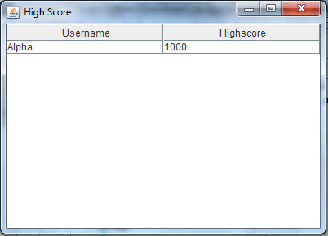

import javax.swing.*;  
import java.awt.*;  
  
public class highscore extends JFrame {  
  
 public highscore(){  
 setTitle("High Score");  
 setDefaultCloseOperation(EXIT_ON_CLOSE);  
 setSize(400, 400);  
  
 String[] header = {"Username","Highscore"};  
 Object[][] data ={  
 {"Alpha","1000"},  
 };  
  
 JPanel panel0 = new JPanel(new GridLayout(10,1));  
 JTable table = new JTable(data,header);  
 panel0.add(new JScrollPane(table));  
 panel0.setLayout(new BorderLayout());  
 panel0.add(table.getTableHeader(), BorderLayout.NORTH);  
 panel0.add(table,BorderLayout.CENTER);  
 add(panel0);  
 setVisible(true);  
 }  
  
}

**B. Fitur Admin**

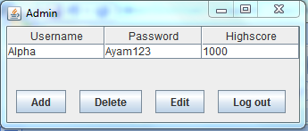

import javax.swing.*;  
import javax.swing.border.EmptyBorder;  
import java.awt.*;  
  
public class admin extends JFrame {  
 JButton badd,bdel,bedi,blog;  
  
 public admin(){  
 setTitle("Admin");  
 setDefaultCloseOperation(EXIT_ON_CLOSE);  
 setSize(400, 400);  
  
 JPanel mainPanel = new JPanel();  
 mainPanel.setLayout(new BoxLayout(mainPanel, BoxLayout.Y_AXIS));  
  
 JPanel p = new JPanel();  
  
 BoxLayout boxlayout = new BoxLayout(p, BoxLayout.X_AXIS);  
  
 badd = new JButton("Add");  
 bdel = new JButton("Delete");  
 bedi = new JButton("Edit");  
 blog = new JButton("Log out");  
  
 p.setLayout(boxlayout);  
  
 String[] header = {"Username","Password","Highscore"};  
 Object[][] data ={  
 {"Alpha","Ayam123","1000"},  
 };  
  
 JPanel panel0 = new JPanel(new GridLayout(10,1));  
 JTable table = new JTable(data,header);  
 panel0.add(new JScrollPane(table));  
 panel0.setLayout(new BorderLayout());  
 panel0.add(table.getTableHeader(), BorderLayout.NORTH);  
 panel0.add(table,BorderLayout.CENTER);  
  
 panel0.setBorder(new EmptyBorder(new Insets(0, 0, 25, 0)));  
 p.setBorder(new EmptyBorder(new Insets(10, 10, 10, 15)));  
  
 p.add(badd);  
 p.add(Box.createRigidArea(new Dimension(15,0)));  
 p.add(bdel);  
 p.add(Box.createRigidArea(new Dimension(15,0)));  
 p.add(bedi);  
 p.add(Box.createRigidArea(new Dimension(15,0)));  
 p.add(blog);  
  
 mainPanel.add(panel0);  
 mainPanel.add(p);  
 add(mainPanel);  
 pack();  
 setVisible(true);  
 }  
  
}

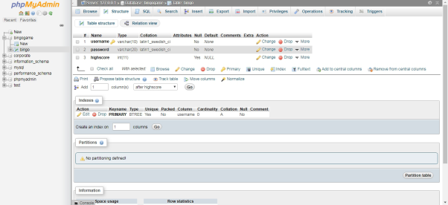**C. Rancangan Database**

**LINK YOUTUBE**